**Assignment 1: Closure addition calculation.**

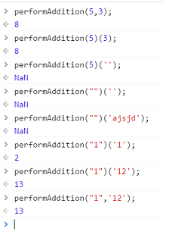

**Assignment 2: Web Worker**

1. Button tomake web worker start functioning at back.



1. 2. After 2 minutes value displayed is:

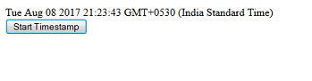

**Assignment 3: LocalStorage**

1. On page load:



1. On valid entries, form is submitted



3. On page reload, vales are inserted into correct textboxes.



4. On clicking, clear form, the local storage and all values are cleared.



**Assignment 4: Singly Linked List**

1. UI

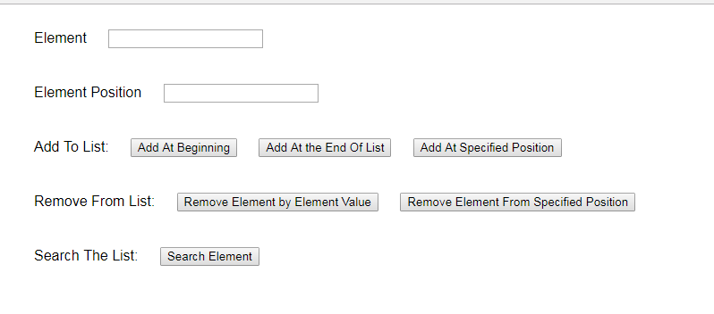

2. Add at beginning



3. Add at end of list

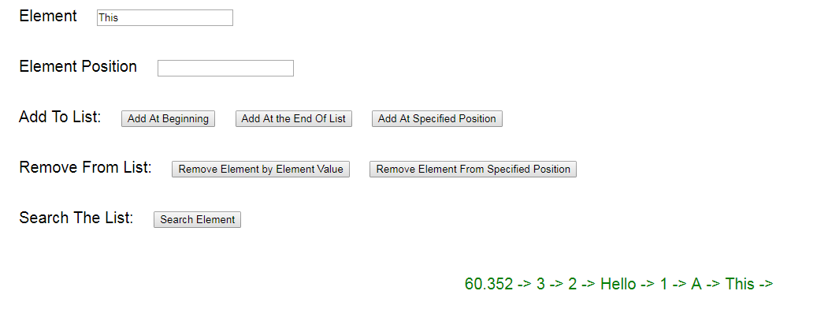

3. Add at specified position in list

i. Invalid entry

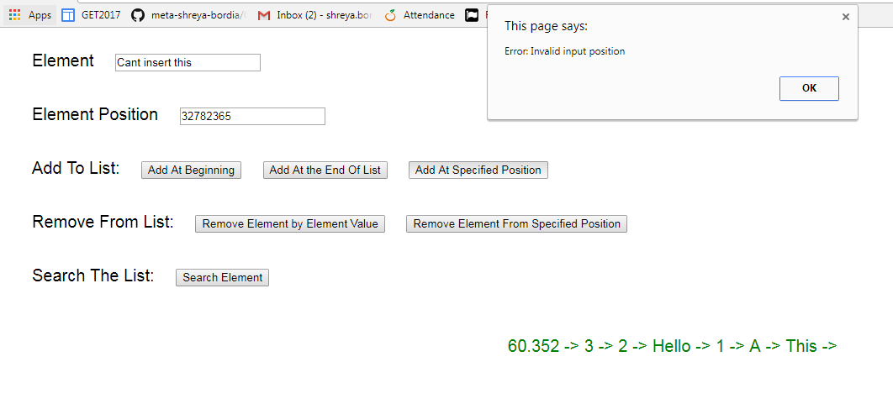

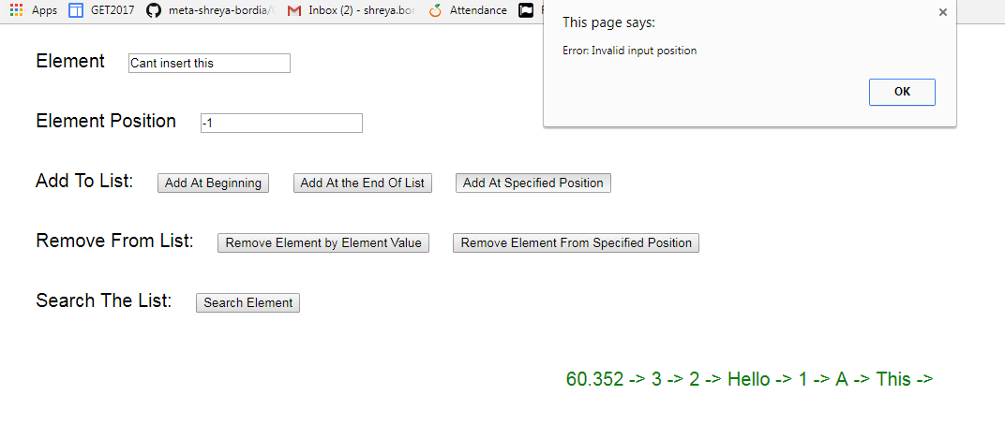

ii. valid entry

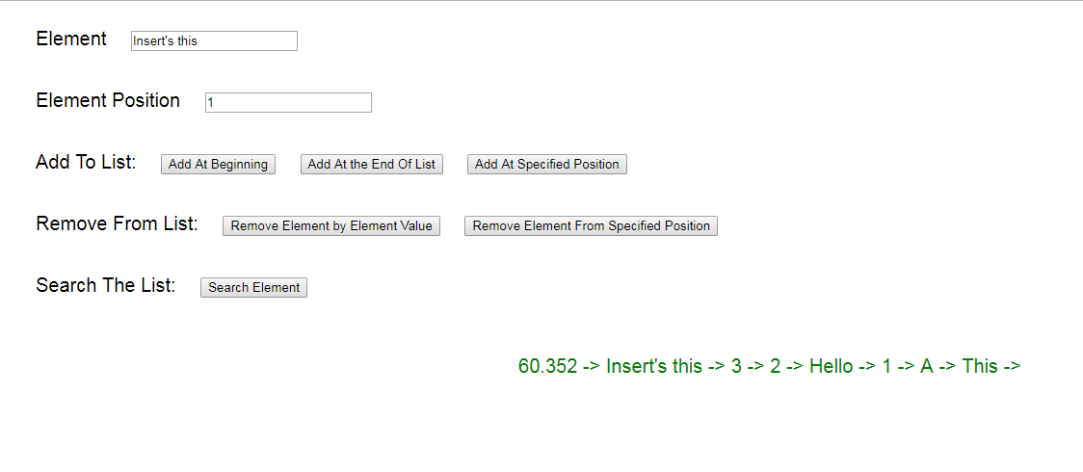

3. Remove element by value

i. When element exists in the list

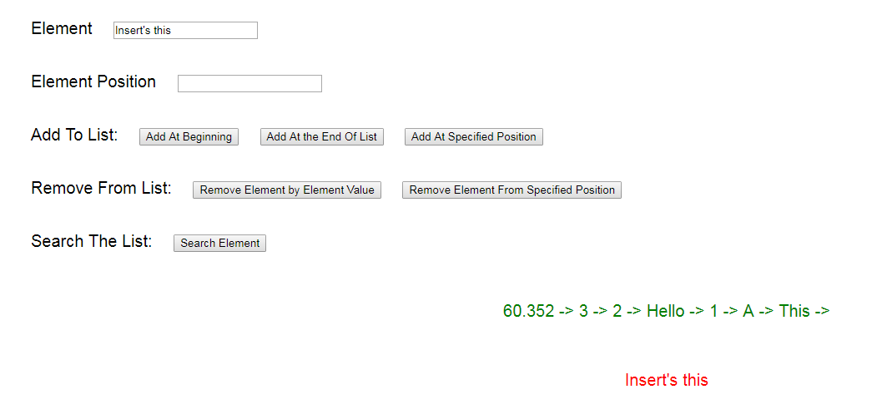

ii. When element does not exist in list

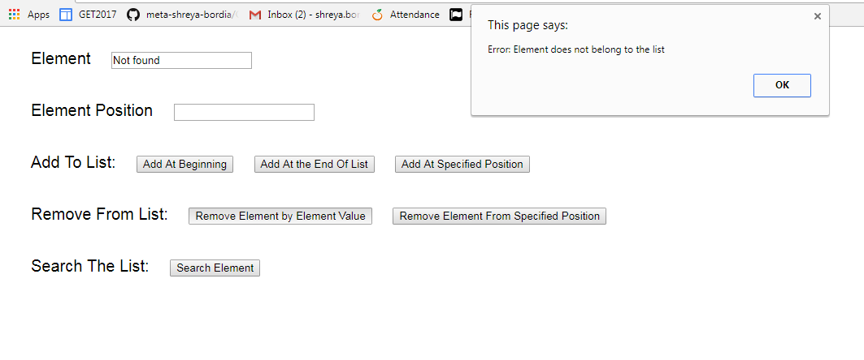

5. Remove element from the specified position

i. Valid position

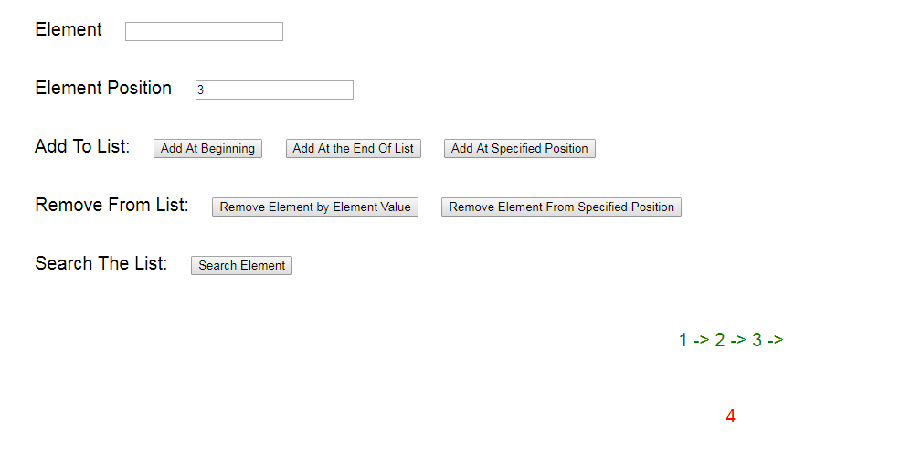

ii. Invalid position

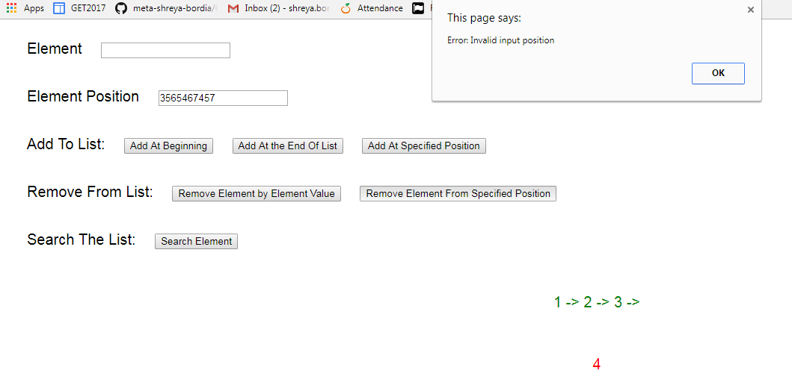

6. Search an element in the list

i. When element belongs to the list

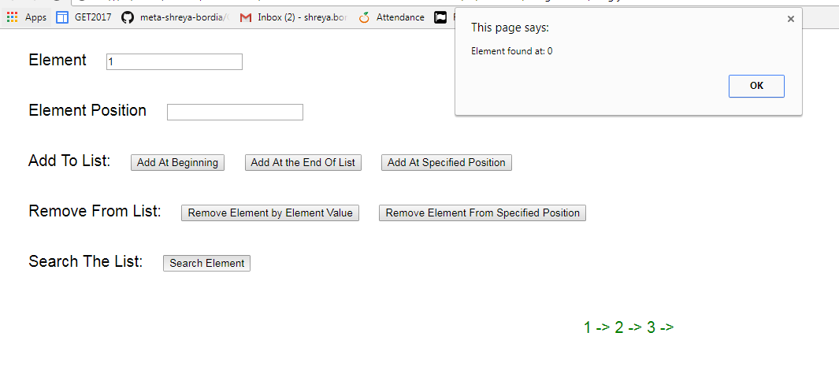

ii. When element does not belong in the list

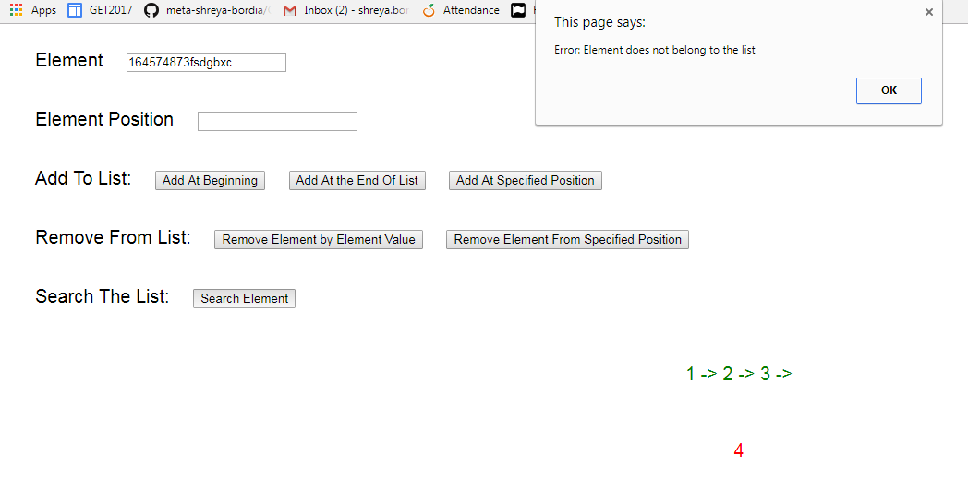

**Assignment 4: Doubly Linked List**

1. UI



2. Add at beginning



3. Add at end of list



3. Add at specified position in list

i. Invalid entry





ii. valid entry



3. Remove element by value

i. When element exists in the list



ii. When element does not exist in list



5. Remove element from the specified position

i. Valid position



ii. Invalid position



6. Search an element in the list

i. When element belongs to the list



ii. When element does not belong in the list

